**Problem Statement 2**

Which month has seen the most number of cancellations due to bad weather?

1. **REGISTER 'piggybank.jar';**
2. **A = load ‘DelayedFlights.csv' USING org.apache.pig.piggybank.storage.CSVExcelStorage(',','NO_MULTILINE','UNIX','SKIP_INPUT_HEADER');**

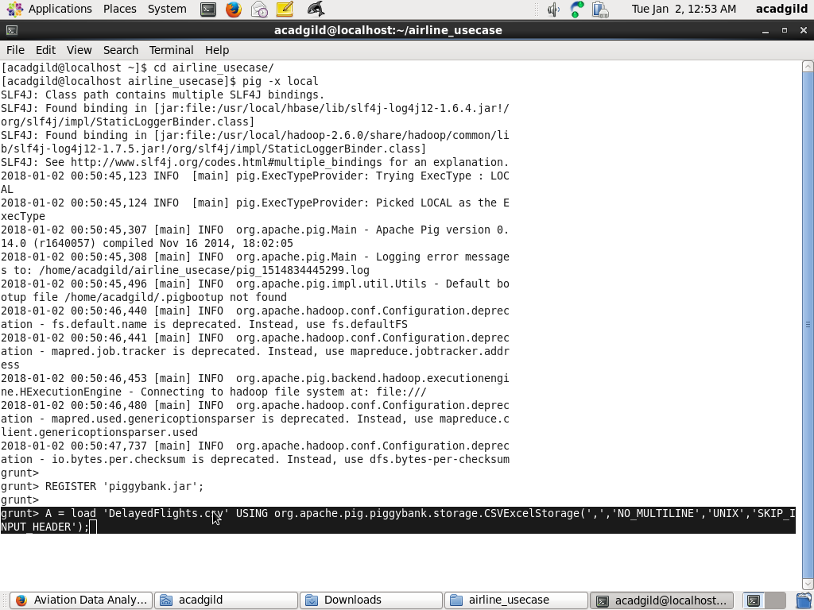

1. **B = foreach A generate (int)$2 as month,(int)$10 as flight_num,(int)$22 as cancelled,(chararray)$23 as cancel_code;**

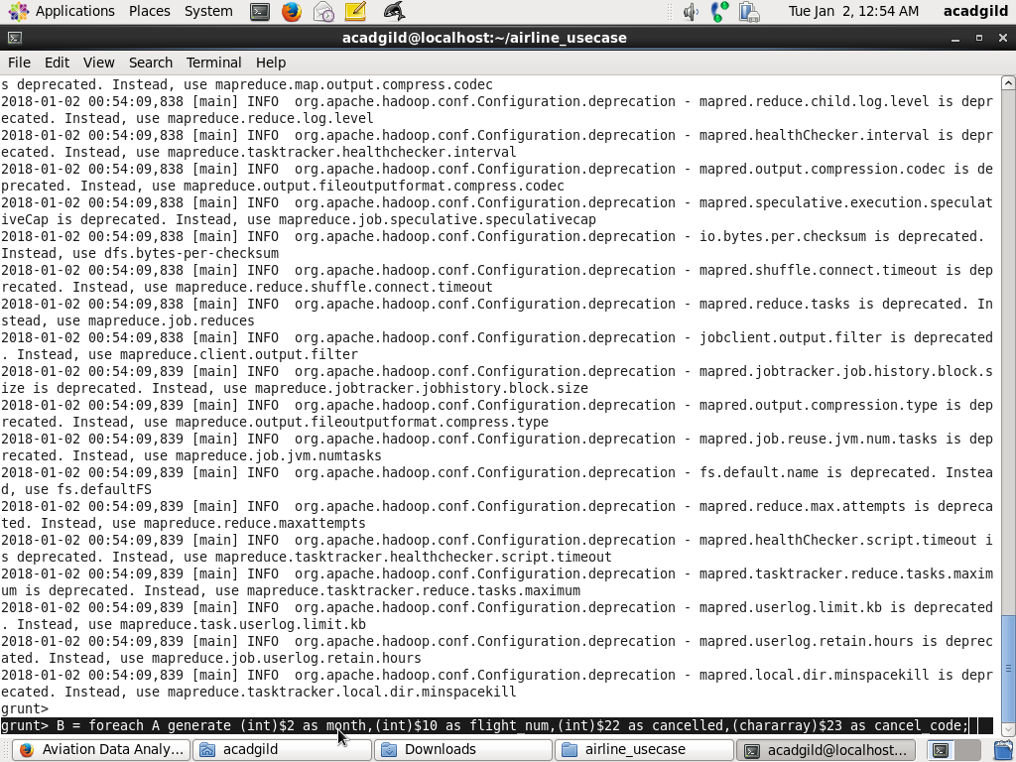

1. **C = filter B by cancelled == 1 AND cancel_code =='B';**
2. **D = group C by month;**
3. **E = foreach D generate group, COUNT(C.cancelled);**

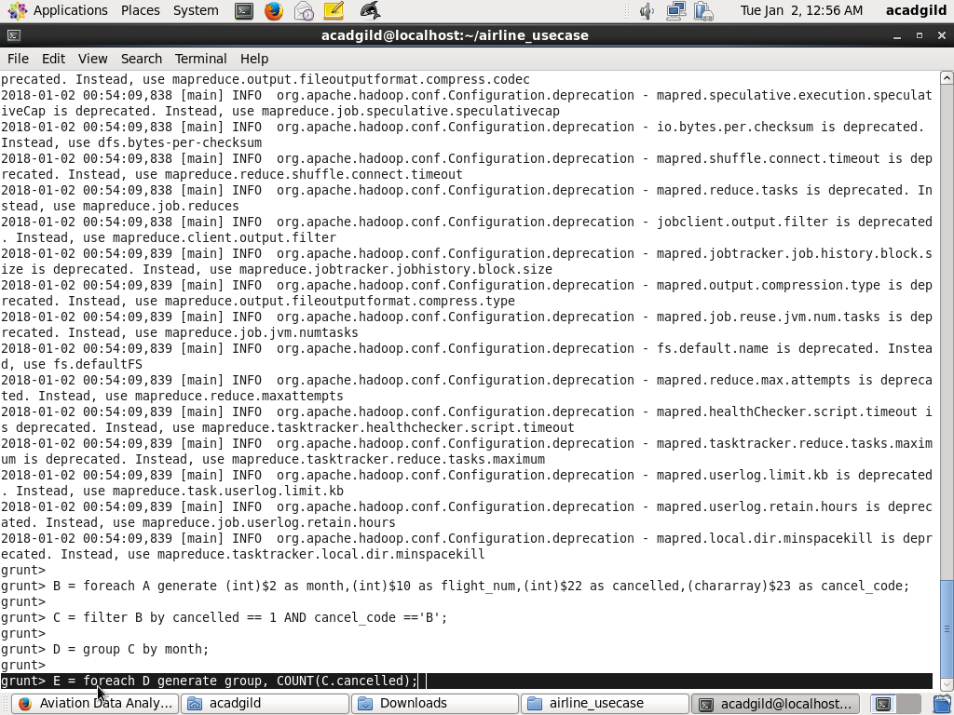

1. **F= order E by $1 DESC;**
2. **Result = limit F 1;**
3. **Dump Result;**

